**MATILLION PERFORMANCE MONITORING DASHBOARD**

**1.1 Total no of project group**

select count(distinct "groupName") as Project_group

from matillio_log.matillion_metadata.matillion_task_history;

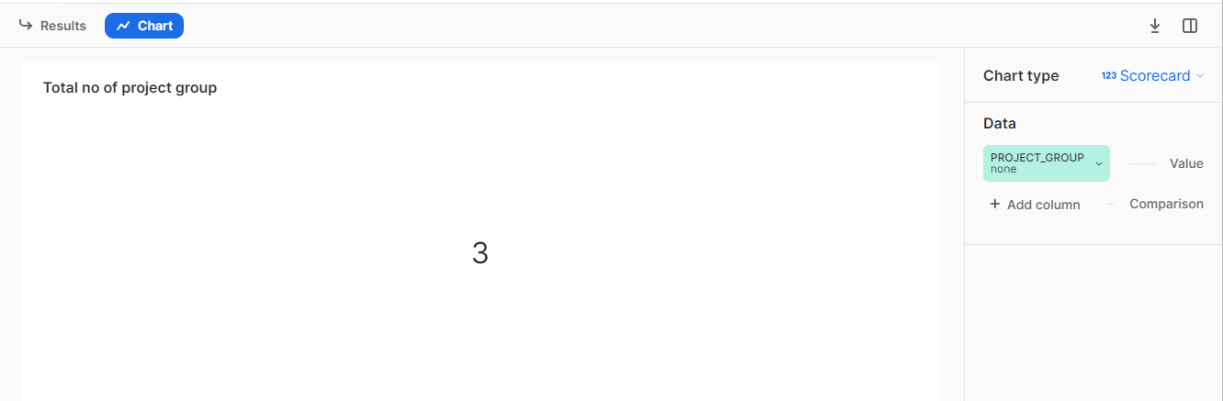

**1.2 Total no of project**

select count(distinct "projectName") as Project

from MATILLIO_LOG.MATILLION_METADATA.MATILLION_TASK_HISTORY;

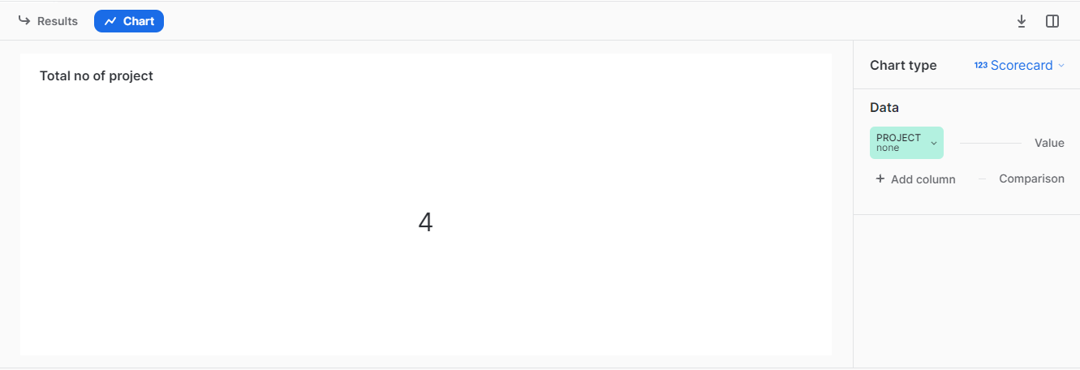

**1.3 Total no of jobs**

select count(distinct "jobName") as job

from matillio_log.matillion_metadata.matillion_task_history;

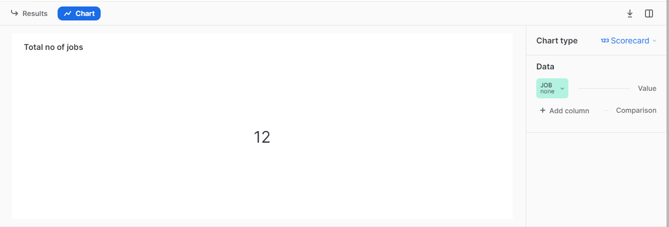

**1.4 Total Jobs Runs**

select count("id") as Total_job_run

from MATILLIO_LOG.MATILLION_METADATA.MATILLION_TASK_HISTORY;

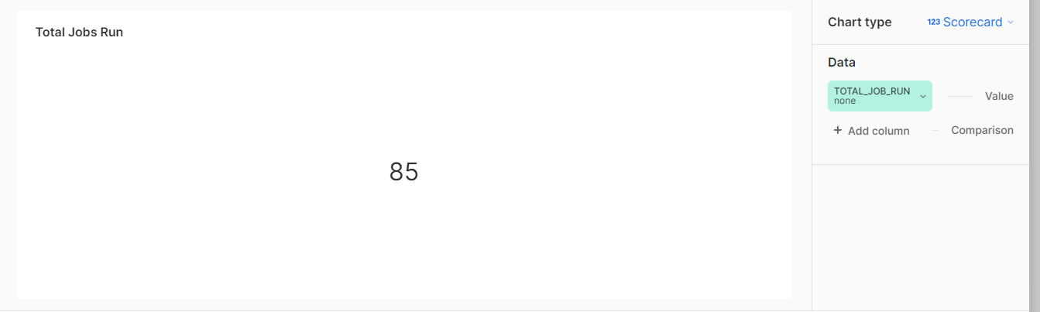

**1.5 Job Success rate %**

SELECT

round((SUM(CASE

WHEN "status" = 'SUCCESS'

THEN 1

ELSE 0

END) /

SUM(CASE

WHEN "status" ='FAILED' or "status" = 'SUCCESS'

THEN 1

ELSE 0

END))*100,2) as success_rate

FROM

MATILLIO_LOG.MATILLION_METADATA.MATILLION_TASK_HISTORY;

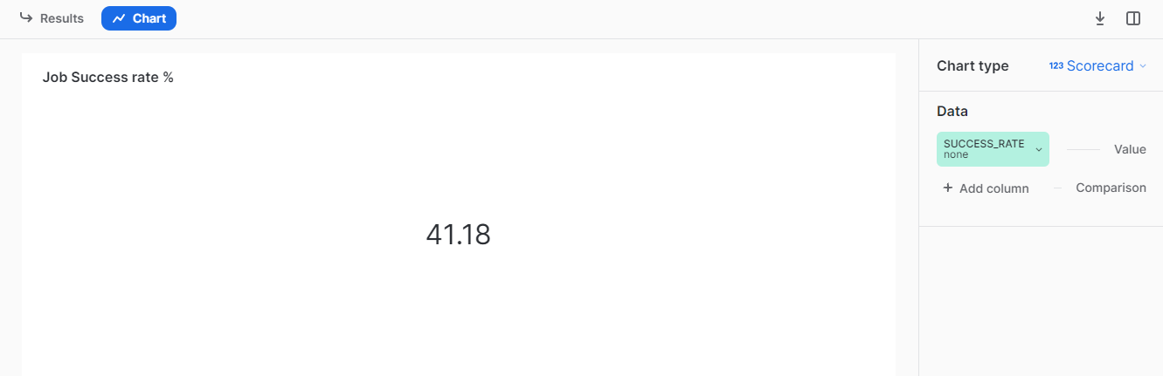

**1.6 No of jobs runs on daily basis**

select "id", "enqueuedTime"

from MATILLIO_LOG.MATILLION_METADATA.MATILLION_TASK_HISTORY;

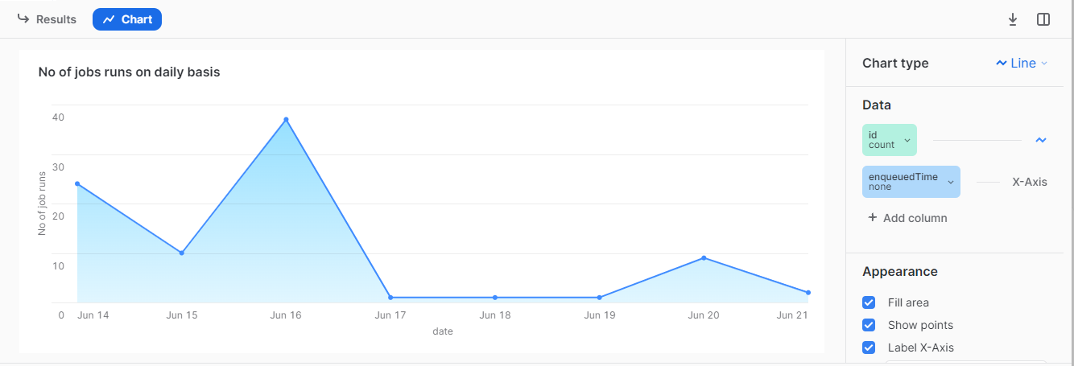

**1.7 No of time each job run**

select "jobName"

from MATILLIO_LOG.MATILLION_METADATA.MATILLION_TASK_HISTORY;

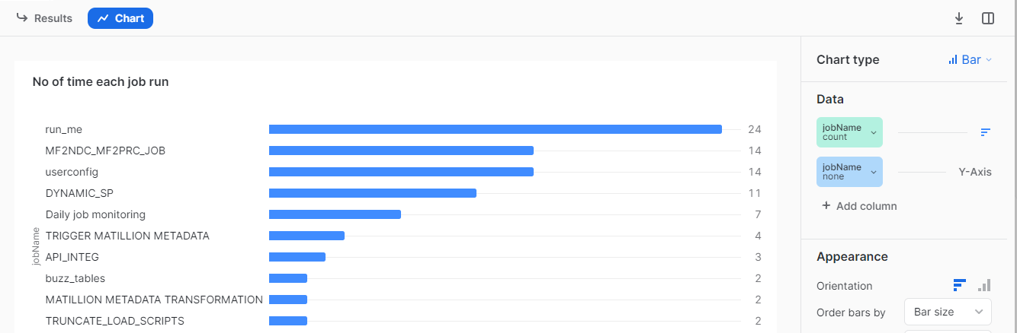

**1.8 Job execution status**

SELECT

SUM(CASE

WHEN "status" = 'SUCCESS'

THEN 1

ELSE 0

END) AS SUCCESS,

SUM(CASE

WHEN "status" ='FAILED'

THEN 1

ELSE 0

END) AS FAILED

FROM

MATILLIO_LOG.MATILLION_METADATA.MATILLION_TASK_HISTORY;

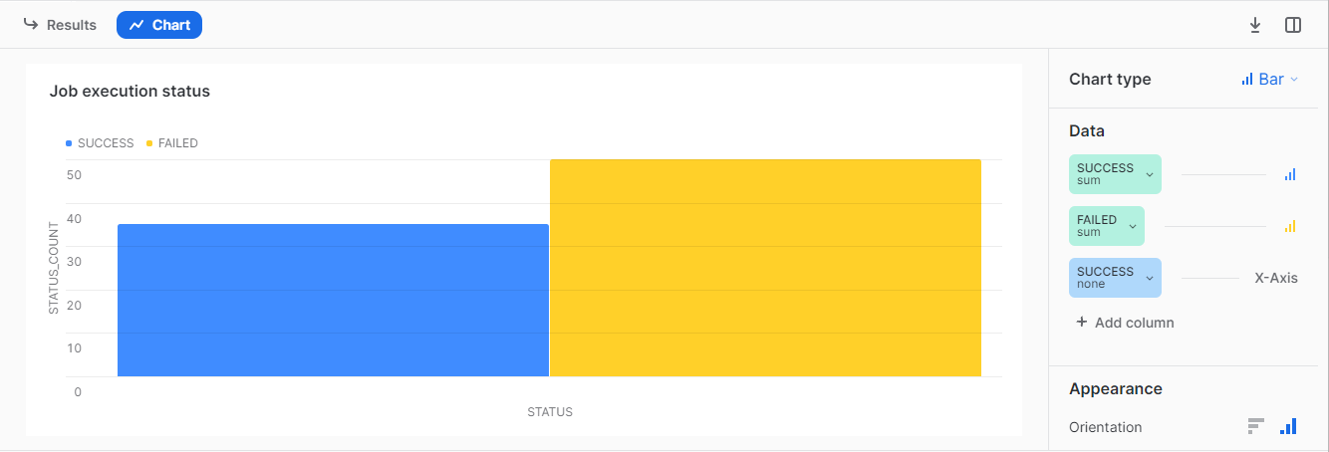

**1.9 Job duration**

select distinct("jobName") ,"duration(inSec)"

from matillio_log.matillion_metadata.matillion_task_history;

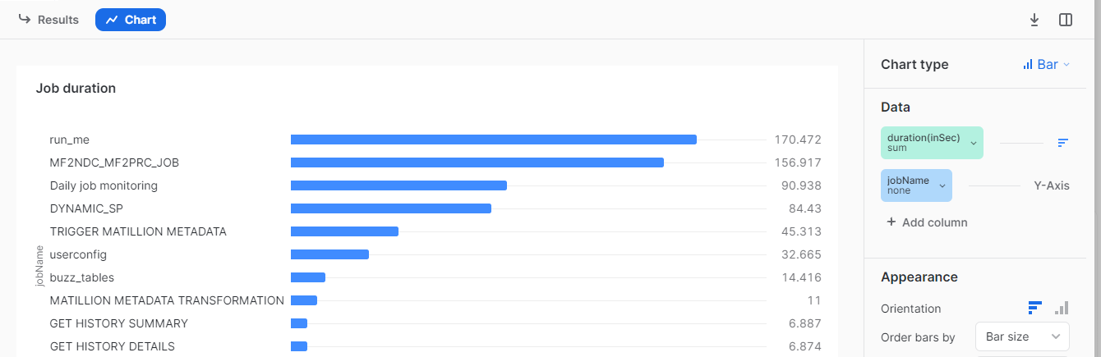

**1.10 No of Errors**

SELECT "message","status"

FROM MATILLIO_LOG.MATILLION_METADATA.MATILLION_TASK_HISTORY

where "status"='FAILED';

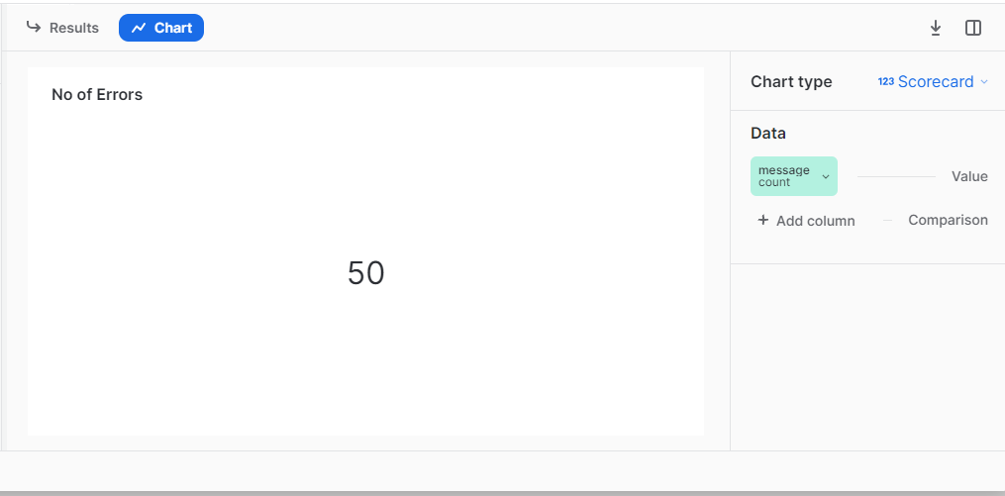

**1.11 No of Minutes wastes in error**

select round(sum("duration(inSec)"),2)/60 as minutes

from MATILLIO_LOG.MATILLION_METADATA.MATILLION_TASK_HISTORY

where "status"='FAILED';

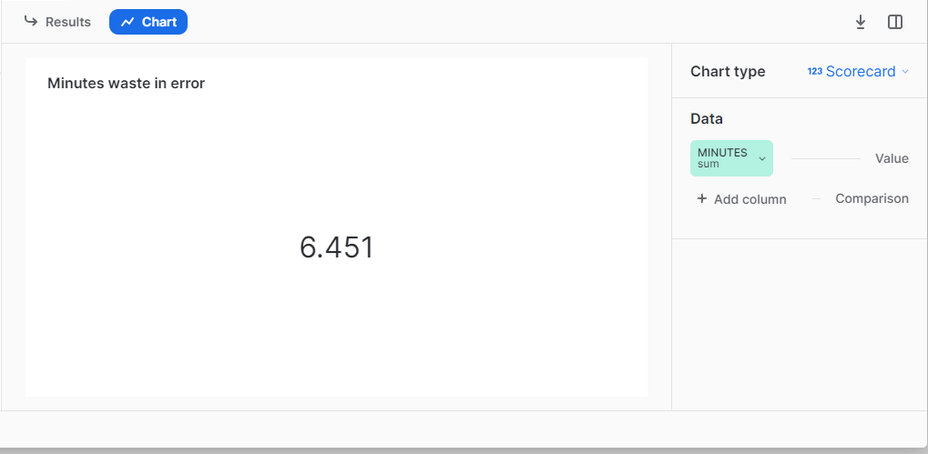

**1.12 Jobs with no of errors**

select "jobName","status"

from MATILLIO_LOG.MATILLION_METADATA.MATILLION_TASK_HISTORY

where "status"='FAILED';

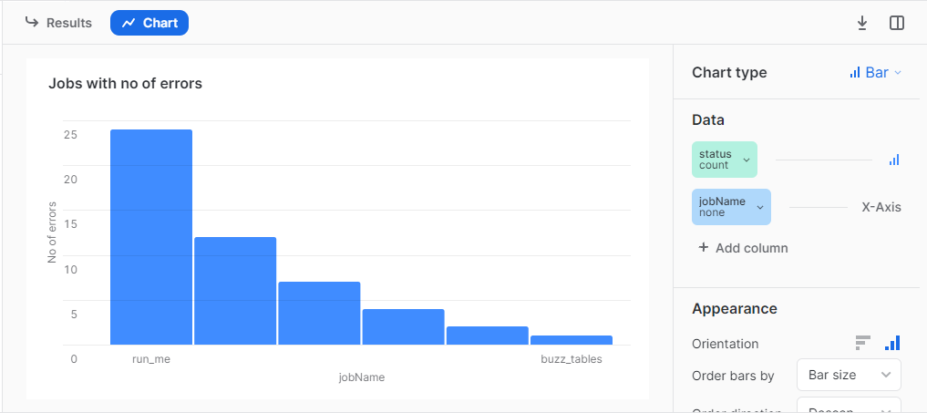

**1.13 Common error messages**

select replace("message",',','') as error_messages,"jobName","startTime"

from MATILLIO_LOG.MATILLION_METADATA.MATILLION_TASK_HISTORY

where "status"='FAILED';

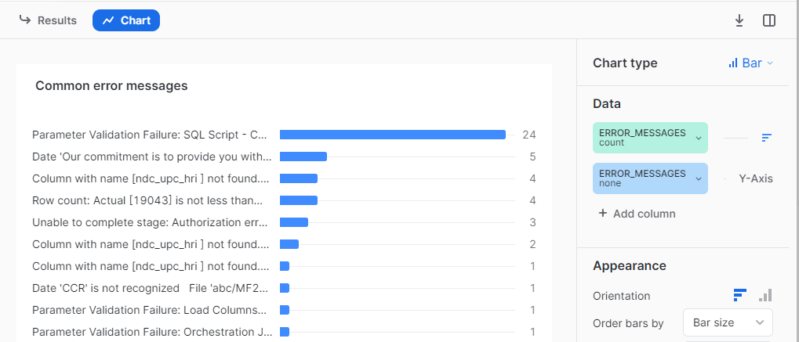

**1.14 Error rate per job**

SELECT

top 7 "jobName",

COUNT(CASE WHEN "status" IN ('FAILED') THEN 1 END) AS event_count,

COUNT(CASE WHEN "status" IN ('SUCCESS','FAILED') THEN 1 END) AS total_sync,

case when total_sync >0 then ROUND( (event_count/total_sync)*100,2) end as ERROR_RATE

FROM MATILLIO_LOG.MATILLION_METADATA.MATILLION_TASK_HISTORY

where "jobName" is not null

GROUP BY

"jobName"

order by ERROR_RATE desc;

